**FOR IMMEDIATE RELEASE**

Contact: Paul Friedman, [paulfriedman@safecountry.org](mailto:paulfriedman@safecountry.org), (703) 585-7626

**“Star Trek” Actress Yetide Badaki joins Safer Country, along with former Virginia Lt. Governor candidate, Hala Ayala, and Andrew Goddard, Legislative Director for the Virginia Center for Public Safety**

*Founded on February 14, 2019, Safer Country is a 501(c)(3) gun tragedy prevention education and advocacy group based in Alexandria, Virginia*

**ALEXANDRIA, September 24, 2024** – Safer Country is proud to announce that well-known actress Yetide has become Safer Country’s first Honorary Chairperson of its Advisory Committee.

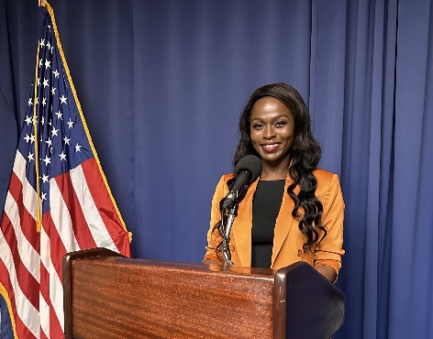   
Yetide is one of Hollywood’s up and coming actress activists. Her resume includes Star Trek: Strange New Worlds, American Gods, Lost, Touch, Criminal Minds, and This Is Us. She will be starring as Queen Nzinga in the Starz/Lionsgate TV series for which she is also executive producer.   
  
She has narrated award winning audio books for such authors as Desmond Tutu, Teju Cole, Nnedi Okorafor, Natasha Bowen and Akwaeke Emezi. A theater actress in Chicago, Badaki won acclaim for her performances at the Victory Gardens Theater and Steppenwolf. Badaki’s film credits include the Disney film RISE, Precipice, A Chance of Rain, What We Found, and Run Fast.

Yetide feels compelled to get involved to protect lives by preventing gun tragedies. In that light, she shared that, “Every time I hear of another school shooting, my heart grows heavy. I have nephews and nieces I adore and it is heartbreaking that children like them go to school every day with the threat of experiencing such violence.”  
  
Further, she emphasized that, “As former First Lady Michelle Obama said during the Democratic National Convention, we all need to **Do Something**. Being a part of action with Safety Country is exactly that. This gives me the opportunity to "do something" about an issue I care deeply about. I hope to be a part of changing our nation for the better.”

Safer Country’s Advisory Committee includes law enforcement officials, business people, and entertainment professionals, among others. [The full list is visible here on the Safer Country website](https://safercountry.org/our-team/).

Safer Country is equally proud to announce the addition of two new Board members this year, Hala Ayala and Andrew Goddard.  
  
**Hala Ayala**, a cybersecurity specialist with over 25 years of experience in national security, is a dedicated public servant..

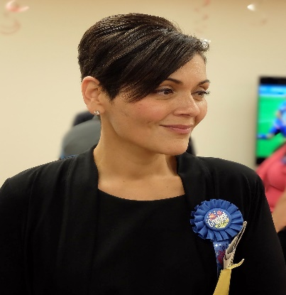

[This Photo](https://en.wikipedia.org/wiki/Hala_Ayala) by Unknown Author is licensed under [CC BY-SA](https://creativecommons.org/licenses/by-sa/3.0/)

As a Delegate and Chief Deputy Whip, Hala worked tirelessly to pass legislation that benefits millions of Virginians. Her efforts have led to significant changes, including expanding background checks to keep guns out of dangerous hands, a measure that has undoubtedly saved lives and made communities safer.

Hala’s personal experience with gun violence has deeply influenced her political career. She understands the pain and trauma it causes, having felt its toll firsthand when her father was killed when she was just two years old. This profound empathy, born from her own experience, has driven her to champion common-sense gun safety reform.

Hala Ayala’s political career is marked by her unwavering determination to advocate for progress in Virginia. Even though she is no longer a legislator, her work to end gun violence continues. She is committed to building on the progress made in Virginia, not only to honor her father but to honor all of the victims of gun violence through tangible action. Her hope is that her dedication will inspire hope for a safer future, which begins with ending the epidemic of gun violence in our country.

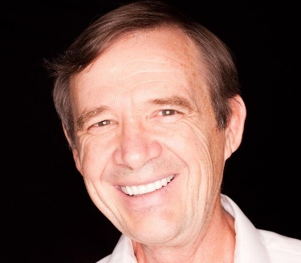**Andrew Goddard** is the Legislative Director for The Virginia Center for Public Safety. Andrew’s son, Colin, was seriously wounded during the Virginia Tech mass shooting on April 16, 2007 and had to undergo multiple operations. Colin is doing well today and has a beautiful family. Andrew was moved by that incident to become one of Virginia’s leading gun safety advocates and is an invaluable source of information to everyone interested in legislation impacting the subject.  
  
Safer Country’s focus is expanding the use of red flag laws. Safer Country initiated and worked with Fairfax County in Virginia to create the first-in-the-nation red flag law public awareness campaign. That campaign is also running in the City of Alexandria.

###

Paul A. Friedman

Executive Director

Safer Country

safercountry.org  
[paulfriedman@safercountry.org](mailto:paulfriedman@safercountry.org)  
703-585-7626